**GE2024 INDIA Data Visualization Project Documentation**

# **PROJECT OVERVIEW**

## PROJECT TITLE: GE2024 INDIA Data Visualization

DATE: June 28,2024

## AUTHOR: Aadhithya Prakash, Kayalvizhi

## PURPOSE: This project aimed to analyze the election results trends

General election of India 2024.

# **DATA SOURCES**

Data source: <https://www.kaggle.com/datasets/nuhmanpk/india-lok-sabha-election-results-2024>

<https://www.kaggle.com/datasets/ajayghuge/lok-sabha-general-election-2024-results-india>

Description:

This dataset contains the complete results of the 2024 Lok Sabha Elections, sourced directly from the **Election Commission of India's** official website through an automated script. The data was scraped on 5th June 2024, one day after the results were officially published.

# **VISUALIZATION DETAILS**

Visualization Tools: Tableau

Types of Visualizations: Line charts, bar charts, pie chart and geographical heat maps.

# **KEY INSIGHTS**

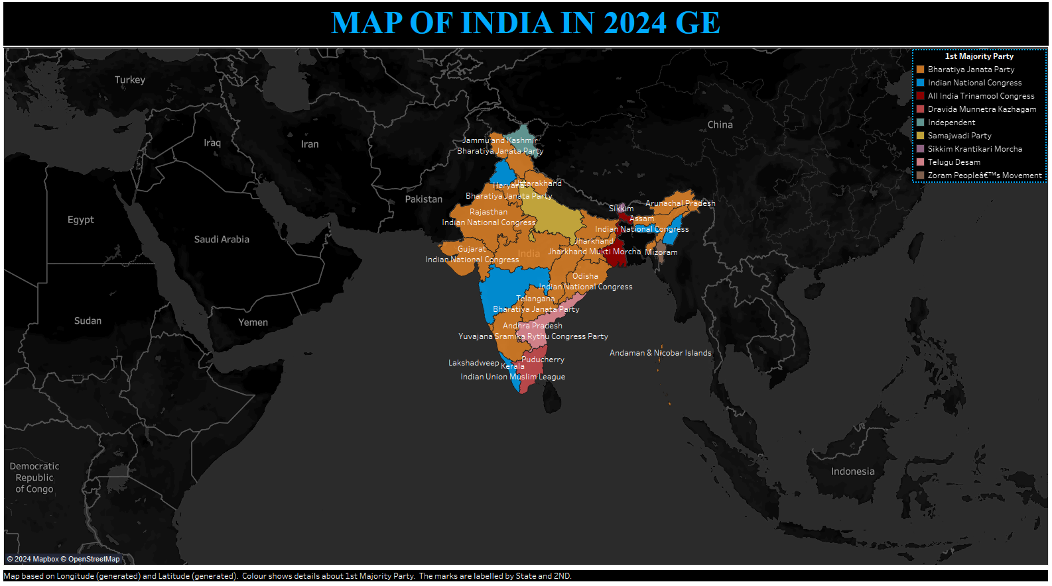

* **STATE** weakly affects **Margin** (23%).
* **Margin** is most unusual in Madhya Pradesh, Gujarat, Uttar Pradesh and Tripura.
* The overall number of results for **Margin** is 543.
* Across all values of **STATE** and **1ST MAJORITY PARTY - 2ND - 3rd L - 4TH - 5TH**, the average of **Margin** is over 162 thousand.
* The average values of **Margin** range from over 2500 to over 549 thousand.
* Uttar Pradesh is the most frequently occurring category of **STATE** with a count of 79 items with **Margin** values (14.5 % of the total).
* Samajwadi Party Bhartiya Janata Party is the most frequently occurring category of **1ST MAJORITY PARTY - 2ND - 3rd L - 4TH - 5TH** with a count of 267 items with **Margin** values (49.2 % of the total).

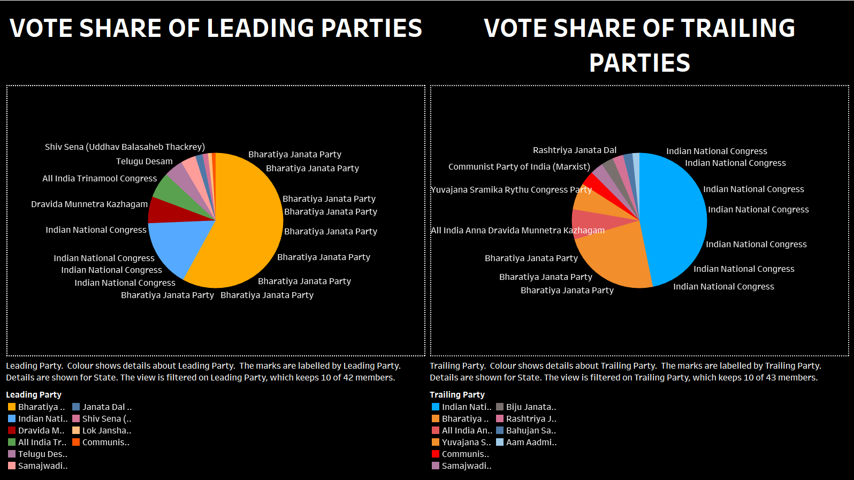

* Over all **leading parties**, the sum of **Margin** is almost 88 million.
* **Margin** ranges from nearly 38 thousand, when **Leading Party** is Apna Dal (Soneylal), to over 46 million, when **Leading Party** is Bhartiya Janata Party.
* **Margin** is unusually high when **Leading Party** is Bhartiya Janata Party, Indian National Congress, Dravida Munnetra Kazhagam and All India Trinamool Congress.
* Over all **trailing parties**, the sum of **Margin** is almost 88 million.
* **Margin** ranges from 0, when **Trailing Party** is (no value), to almost 36 million, when **Trailing Party** is Indian National Congress.
* **Margin** is unusually high when **Trailing Party** is Indian National Congress, Bhartiya Janata Party, All India Anna Dravida Munnetra Kazhagam and Yuvajana Sramika Rythu Congress Party.

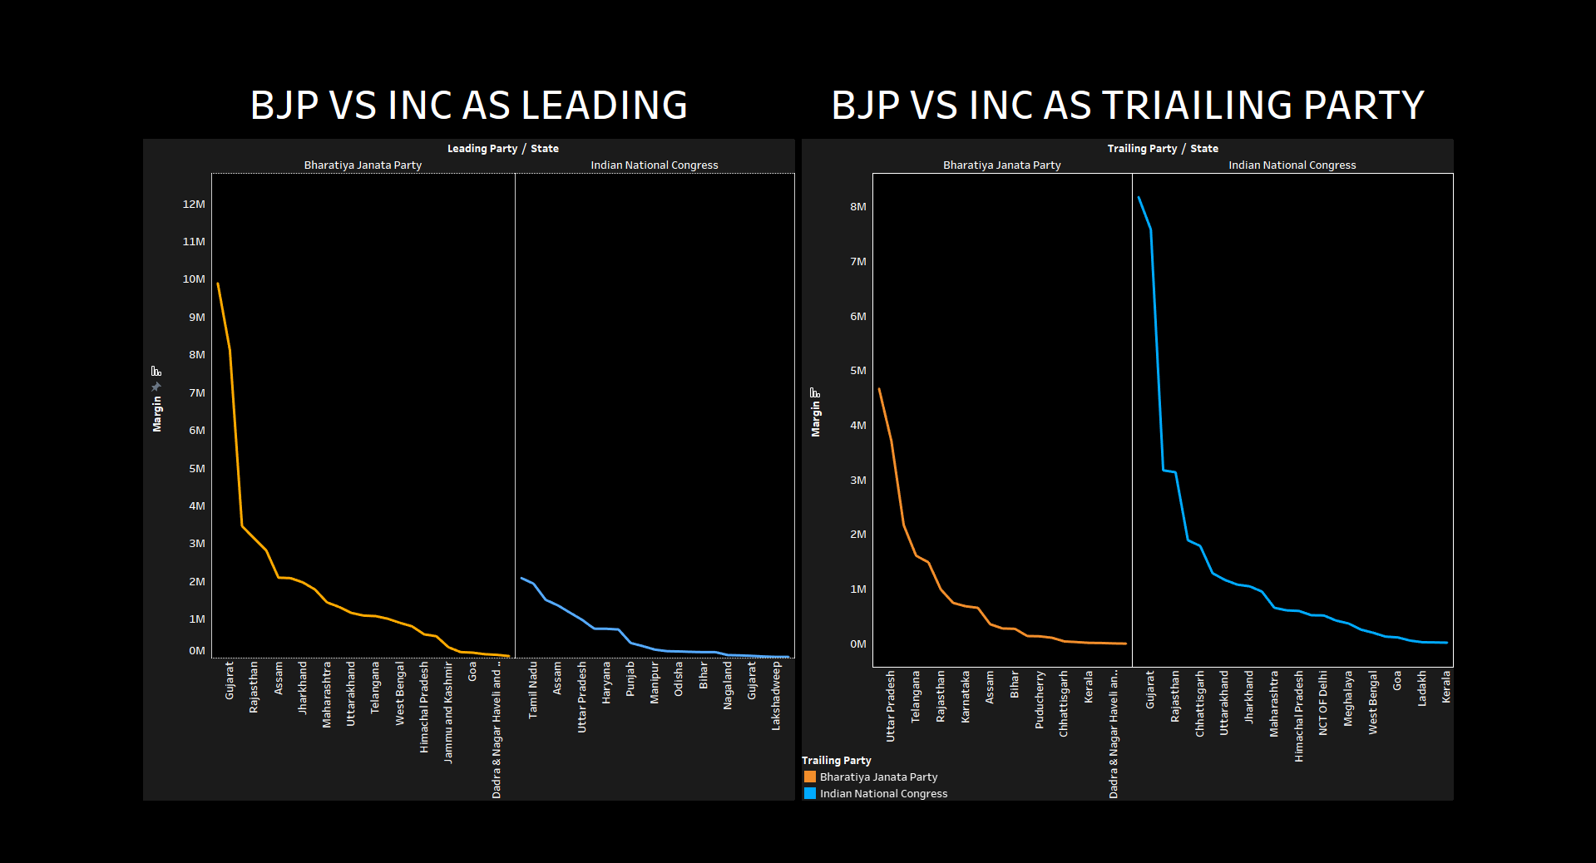

* Across all **leading parties**, the sum of **Margin** is over 59 million.
* **Margin** ranges from over thirteen million, when **Leading Party** is Indian National Congress, to over 46 million, when **Leading Party** is Bhartiya Janata Party.
* Over all **trailing parties**, the average of **Margin** is almost 169 thousand.
* The average values of **Margin** range from nearly 119 thousand, occurring when **Trailing Party** is Bhartiya Janata Party, to almost 215 thousand, when **Trailing Party** is Indian National Congress.
* **Trailing Party** weakly affects **Margin** (10%).
* Indian National Congress is the most frequently occurring category of **Trailing Party** with a count of 167 items with **Margin** values (52.2 % of the total).

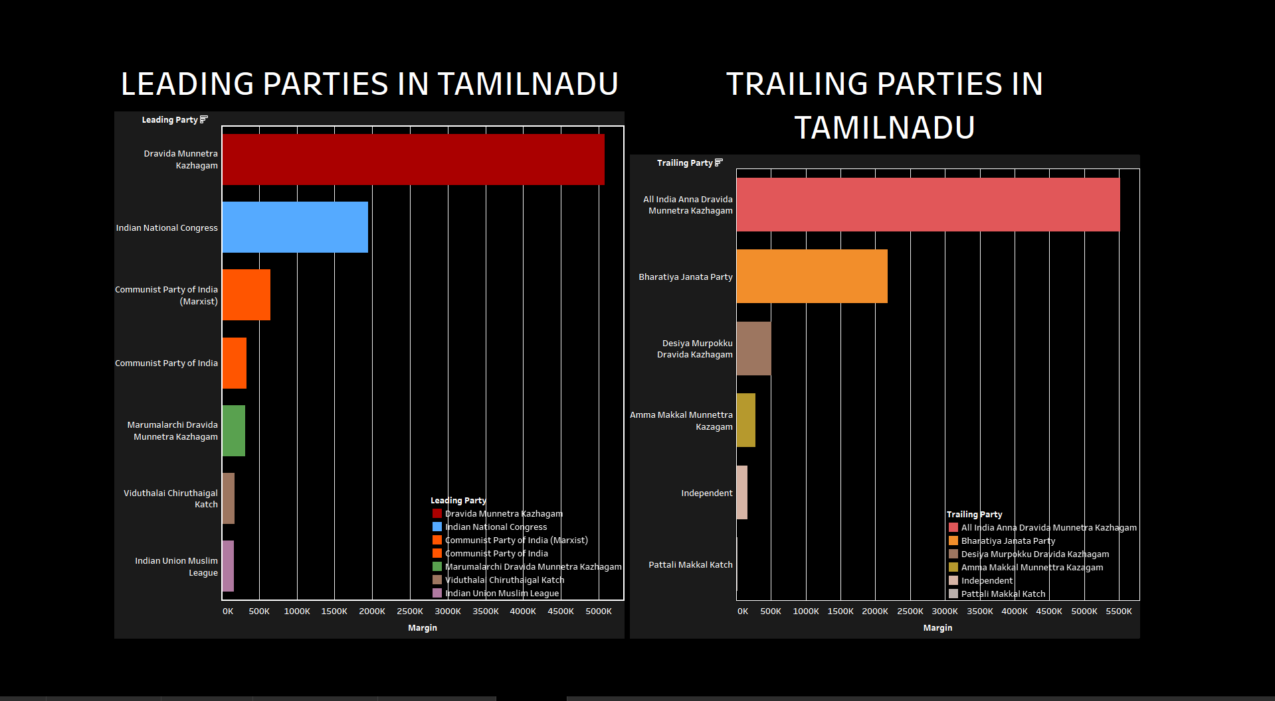

* Over all **leading parties**, the sum of **Margin** is nearly 8.7 million.
* **Margin** ranges from almost 167 thousand, when **Leading Party** is Indian Union Muslim League, to almost 5.1 million, when **Leading Party** is Dravida Munnetra Kazhagam.
* **Margin** is unusually high when **Leading Party** is Dravida Munnetra Kazhagam.
* Over all **trailing parties**, the sum of **Margin** is nearly 8.7 million.
* **Margin** ranges from over 21 thousand, when **Trailing Party** is Pattali Makkal Katch, to over 5.5 million, when **Trailing Party** is All India Anna Dravida Munnetra Kazhagam.
* **Margin** is unusually high when **Trailing Party** is All India Anna Dravida Munnetra Kazhagam.

# **Design Choices**

Color Palette: Used a contrasting color scheme to differentiate between parties and margin vote trends across different regions.

Typography: Utilized a sans-serif font for clarity and readability.

Interactivity: Implemented interactive filters to allow us to drill down into regional election statistical data.

Conclusion

This data visualization project successfully analyzed the trends in the 2024 General Election results of India. The analysis revealed several interesting patterns, including the significant impact of leading parties on margin of victory, with Bhartiya Janata Party (BJP) and Indian National Congress (INC) emerging as the frontrunners. Additionally, state had a weaker influence on margin compared to leading parties. The visualizations employed contrasting colors, clear fonts, and interactive filters to effectively communicate these insights.

In future analyses, it would be beneficial to explore factors beyond leading parties and state that might influence election margins. This could involve incorporating demographic data, economic indicators, and social media sentiment to gain a more nuanced understanding of the electoral landscape.

PROJECT LINK: https://github.com/AadhithyaPrakash/GE2024IND_VISUALIZTION